**WADS Lab Task 9 (06 Feb 2025)**

**HU22CSEN0100287**

**Sai Ganesh Eswaraprasad**

1. ***Display XML data using XSLV***

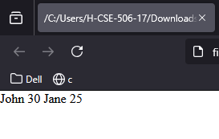

CODE:

[data.xml]

<?xml version="1.0" encoding="UTF-8"?>

<?xml-stylesheet type="text/xsl" href="style.xsl"?>

<people>

  <person>

    <name>John</name>

    <age>30</age>

  </person>

  <person>

    <name>Jane</name>

    <age>25</age>

  </person>

</people>

[style.xsl]

<?xml version="1.0" encoding="UTF-8"?>

<xsl:stylesheet version="1.0" xmlns:xsl="http://www.w3.org/1999/XSL/Transform">

  <xsl:template match="/">

    <html>

      <body>

        <h2>People List</h2>

        <table border="1">

          <tr>

            <th>Name</th>

            <th>Age</th>

          </tr>

          <xsl:for-each select="people/person">

            <tr>

              <td><xsl:value-of select="name"/></td>

              <td><xsl:value-of select="age"/></td>

            </tr>

          </xsl:for-each>

        </table>

      </body>

    </html>

  </xsl:template>

</xsl:stylesheet>

1. ***JS using Regular Expressions search(),replace***()

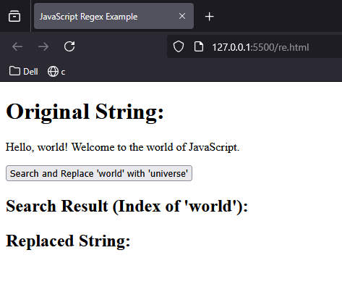

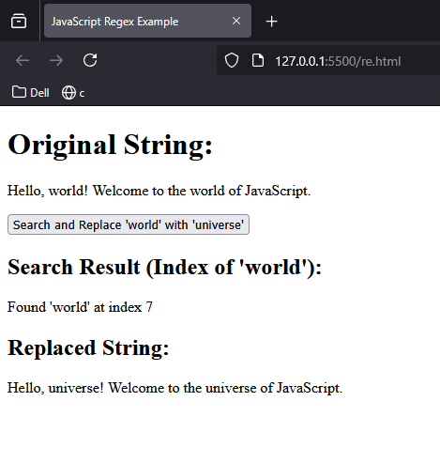

CODE:

[re.html]

<!DOCTYPE html>

<html lang="en">

<head>

  <meta charset="UTF-8">

  <meta name="viewport" content="width=device-width, initial-scale=1.0">

  <title>JavaScript Regex Example</title>

</head>

<body>

  <h1>Original String:</h1>

  <p id="original">Hello, world! Welcome to the world of JavaScript.</p>

  <button onclick="replaceText()">Search and Replace 'world' with 'universe'</button>

  <h2>Search Result (Index of 'world'):</h2>

  <p id="searchResult"></p>

  <h2>Replaced String:</h2>

  <p id="replaced"></p>

  <script>

    function replaceText() {

      var str = document.getElementById("original").innerText;

      var searchResult = str.search(/world/);

      document.getElementById("searchResult").innerText = searchResult !== -1 ? `Found 'world' at index ${searchResult}` : "'world' not found";

      var newStr = str.replace(/world/g, "universe");

      document.getElementById("replaced").innerText = newStr;

    }

  </script>

</body>

</html>